Semi-Structured Dataset

What is Semi-Structured Dataset
# Source: AI Source: Provided by: [Data Path: Persons Table -> ID Column: 1, Name_En Column: Motasem Essam] -> From: [Chatgpt (GPT‑5 Mini)] on [12/10/2025]
A semi-structured dataset contains data that does not fit neatly into rows and columns like structured data, but still has some organizational properties or tags to make it easier to analyze.
It is between structured and unstructured data.

Key Characteristics of Semi-Structured Datasets
# Source: AI Source: Provided by: [Data Path: Persons Table -> ID Column: 1, Name_En Column: Motasem Essam] -> From: [Chatgpt (GPT‑5 Mini)] on [12/10/2025]
- Flexible Schema
  - Data may have a variable structure.
  - Not all records need to have the same fields.
- Organized with Tags or Markers
  - Uses formats like XML, JSON, YAML to indicate data relationships.
  - Allows programs to parse and understand the data.
- Partially Queryable
  - Some tools (like NoSQL databases) can query it, but it’s not as straightforward as SQL tables.
- Supports Complex Data
  - Can include arrays, nested objects, or hierarchical relationships.

Examples of Semi-Structured Datasets
# Source: AI Source: Provided by: [Data Path: Persons Table -> ID Column: 1, Name_En Column: Motasem Essam] -> From: [Chatgpt (GPT‑5 Mini)] on [12/10/2025]
Example 1 – JSON Format (Student Record)
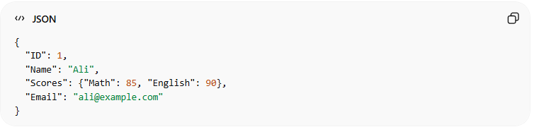
{
"ID": 1,
"Name": "Ali",
"Scores": {"Math": 85, "English": 90},
"Email": "ali@example.com"
}
- Nested structure: "Scores" contains multiple subjects.
- Not all students must have the same fields.
Example 2 – XML Format (Book Data)
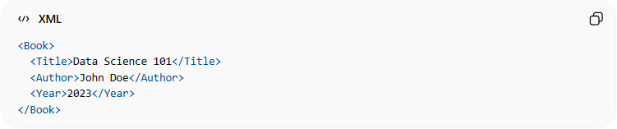
<Book>
<Title>Data Science 101</Title>
<Author>John Doe</Author>
<Year>2023</Year>
</Book>
- Tags <Title>, <Author> help organize data.
- Flexible: some books may have <Publisher> or <ISBN> tags.

Where Semi-Structured Data Is Used
# Source: AI Source: Provided by: [Data Path: Persons Table -> ID Column: 1, Name_En Column: Motasem Essam] -> From: [Chatgpt (GPT‑5 Mini)] on [12/10/2025]
- NoSQL Databases (MongoDB, Couchbase)
- APIs that return JSON or XML
- Web data and logs (social media posts, sensor data)

Advantages
# Source: AI Source: Provided by: [Data Path: Persons Table -> ID Column: 1, Name_En Column: Motasem Essam] -> From: [Chatgpt (GPT‑5 Mini)] on [12/10/2025]
- Flexible and can handle variable or nested data.
- Easier to integrate from multiple sources compared to fully structured datasets.
- Can represent hierarchical relationships.

Disadvantages
# Source: AI Source: Provided by: [Data Path: Persons Table -> ID Column: 1, Name_En Column: Motasem Essam] -> From: [Chatgpt (GPT‑5 Mini)] on [12/10/2025]
- More complex to query than structured datasets.
- Not as efficient for large-scale analytical queries.

✅ In simple terms:
# Source: AI Source: Provided by: [Data Path: Persons Table -> ID Column: 1, Name_En Column: Motasem Essam] -> From: [Chatgpt (GPT‑5 Mini)] on [12/10/2025]
A semi-structured dataset has some organization (tags or fields) but does not follow strict rows and columns, making it flexible for complex or hierarchical data.

